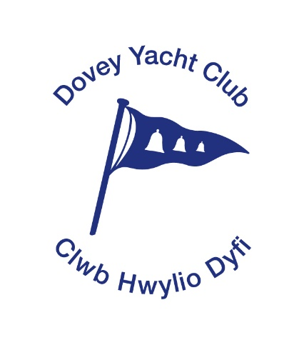

**Membership Secretary** **– David Mason**

Dovey Yacht Club/ David Mason

Clwb Hwylio Dyfi 177 Chester Road

The Wharf Macclesfield

Aberdovey Cheshire

Gwynedd LL35 0ED SK11 8QA

01654 767607 01625 427882

Email: david.mason@doveyyachtclub.org.uk

A Company limited by guarantee.

Registered in Wales No: 09672634

Website: www.doveyyachtclub.org.uk

**APPLICATION FORM FOR FULL MEMBERSHIP - 2018**

**A. SUBSCRIPTIONS**

**Type Definition**

**Family**  Spouse / partner and all children who are below 18 years of age on **£175.00**

1st January 2018, there is no Joining Fee

**Single** Age 29 years or over on 1st January 2018, there is no Joining Fee **£135:00**

**Young Person** Age 18 years to 29on 1st January2018  **£65:00**

**Junior** Below the age of 18 years on 1st January 2018 and not included in a **£40:00**

Family Membership

**Senior Citizen** Senior Citizen members with at least 5 years continuous membership who are of **£80:00**

State Retirement Age on 1st January 2018

**Aberdovey Business** (see Bye Laws for details). **£265:00 + VAT**

**B. CRAFT FEES** - Dinghy  **£140:00**

Second Dinghy or Craft **£75:00**

Junior Dinghy **£65:00**

Sailboards **free**

Multihull Dinghy **£200:00**

**C. USE OF CLUB BOATS -** by Full members not paying a craft fee **£140:00**

by Junior members not paying a craft fee **£65:00**

**PLEASE COMPLETE ALL DETAILS OVERLEAF IN BLOCK CAPITALS**

**PLEASE USE DIFFERENT FORM FOR SOCIAL OR TEMPORARY MEMBERSHIP**

Page 1 of 3

**APPLICATION FOR FULL MEMBERSHIP OF DOVEY YACHT CLUB/CLWB HWYLIO DYFI**

**Applicant Surname Forename Title Occupation** S**pouse Forename Title**

**Children (under 18): Forename Date of Birth Age (on 1/1/2018)**

**Child 1**

**Child 2**

**Child 3**

**Main Interest:** Cruiser / Dinghy / Sailboard / Canoe / Power Boat / Waterski / Fishing

**Main Address:**

**L No: Home Tel No:**

**Loc/Mob Tel No:**

**Local address:**

**£  A**

**E-mail address:**

**Post Code**

**I agree to receive by email and publication on the Club’s website all communications from the Club including notices of meetings of members**

**YES/NO**

**Please detail any qualifications you have that could be of potential use to DYC (e.g. RYA / First Aid / Catering etc.):**

Organisation - Qualification Type - Valid to -

**TYPE OF MEMBERSHIP APPLIED FOR:**

**A**

**£**

**Family** / Single / Student / Junior / Senior Citizen / Business

**CRAFT TYPE:** Codes: C=Cruiser / D1=Dinghy / D2=2nd Dinghy/ S1=Sailboard / M=Multihull

**£ B**

**Code Craft Class Craft Name / Number Craft Hull / Deck colour Fee**

**£**

**£ B**

**£ B**

**£  B**

**£**

**£**

**USE OF CLUB BOATS BY MEMBERS NOT PAYING A CRAFT FEE:**

**TOTAL AMOUNT DUE (A+B+C)**

**£**

Page 2 of 3

Every member will comply with the Articles of Association and Bye Laws of the Club and any house rules. Any refusal or neglect to do so, or any conduct which in the opinion of the Directors is either unworthy of a member, or, otherwise injurious to the interests of the Club, shall render a Member liable to disciplinary action which may include expulsion or non-renewal of membership.

Please make cheques payable to “**Dovey Yacht Club/Clwb Hwylio Dyfi”** and send, with this form, to the Membership Secretary at either of the addresses shown overleaf.

**CONDITIONS OF MEMBERSHIP**

1. Full Members agree to be a member of Dovey Yacht Club / Clwb Hwylio Dyfi, a company limited by guarantee (company number 9672634) and to be bound by the provisions of the articles of association and bye laws of the company and house rules for the use of the clubhouse.
2. Associate Members agree to membership in accordance with the terms of the articles of association and bye laws of the company and house rules for the use of the clubhouse.
3. All members’ details are recorded on a computer system which is used solely to assist with the administration of the Club the keeping of the register of members and the production of the Club Handbook.
4. It is the responsibility of each member to be insured for third party liability of at least £3,000,000 for the use of craft owned or used by them or any other person.
5. The parent or guardian of any associate member under the age of 18 agrees that such persons are their sole responsibility and at no time does any responsibility rest with the Club or its officers, members or employees.

**DECLARATION**

I/We agree to the conditions of membership of the Club and confirm that any craft owned by me/us is covered by the required third party insurance.

All persons over 18 included in a membership must sign:

Signed Date

Signed Date

**Membership Secretary** **– David Mason**

Dovey Yacht Club/ David Mason

Clwb Hwylio Dyfi 177 Chester Road

The Wharf Macclesfield

Aberdovey Cheshire

Gwynedd LL35 0ED SK11 8QA

01654 767607 01625 427882

Email: davidalanmason@gmail.com

Page 3 of 3